|  |
| --- |
| Proggrs |
| FANTASY HALLOWEEN SHOOTER |
| **[A space shooter game]** |
| Version #01  All work Copyright © 2020 by Rohan Juneja.  All rights reserved. |
| **Rohan Juneja - 300987725** |
|  |

|  |
| --- |
| April 06, 2020 |

**Table of Contents**

Table of Contents

**Version History3**

**Game Overview4**

**Game Mechanics4**

**Controls4**

**Saving and Loading4**

**Interface Sketch4**

**Game World7**

**Levels7**

**Characters8**

**Enemies8**

**Weapons8**

**Scoring8**

**Sound Index9**

**Art/Multimedia Index9**

**Version History**

Version 01: Initial Commit

* Added Player
* Added boss, enemies, health bars, lives counter, scores counter
* Added Start screen
* Added End Scene
* Added Final Boss level
* Added Transition Scene from level 1 to boss level
* Added shooting ability and powerups

Version 02: Second Commit

* Added Instructions Button
* Added Instructions Scene
* Added Home button in instructions scene
* Added press ESC to exit feature

Version 03: Fixed Boss

* Fixed boss moving ability
* Fixed Enemies count

Version 04: Final Version

* Added Internal Documentation
* Finalized the game

1. **Game Overview**

In the game player must avoid enemies and bullets and kill enemies in order to progress in the game. To complete a the initial level, the player has to score 5000 points and then boss level appears.

1. **Game Play Mechanics**

The game is a 2D bullet shooter with a [camera perspective]

1. **Controls**

For movement player will use mouse. Players moves around wherever the mouse moves. Player can only move in the 50% of the screen.

1. **Saving and Loading**

There is no saving and loading feature

1. **Interface Sketch**

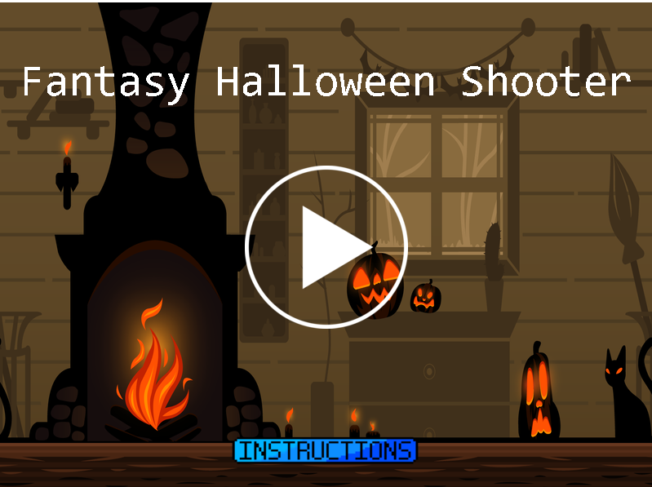

**Figure 1: Main Screen.**

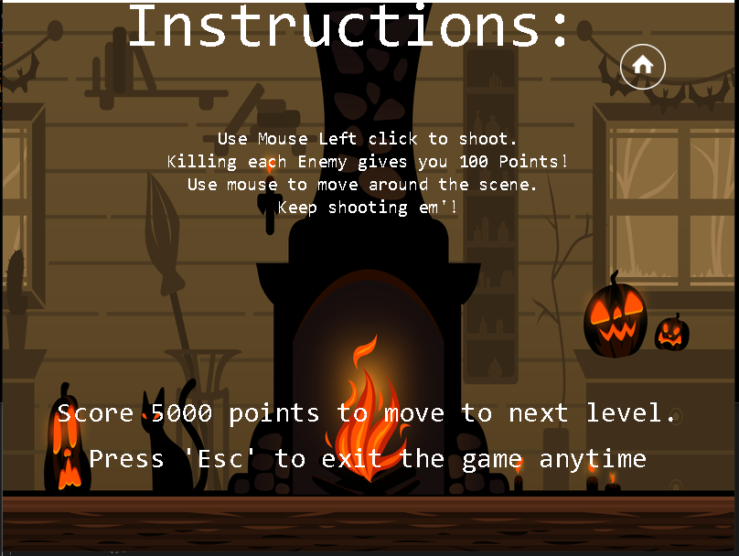

**Figure 2: Instructions Screen**

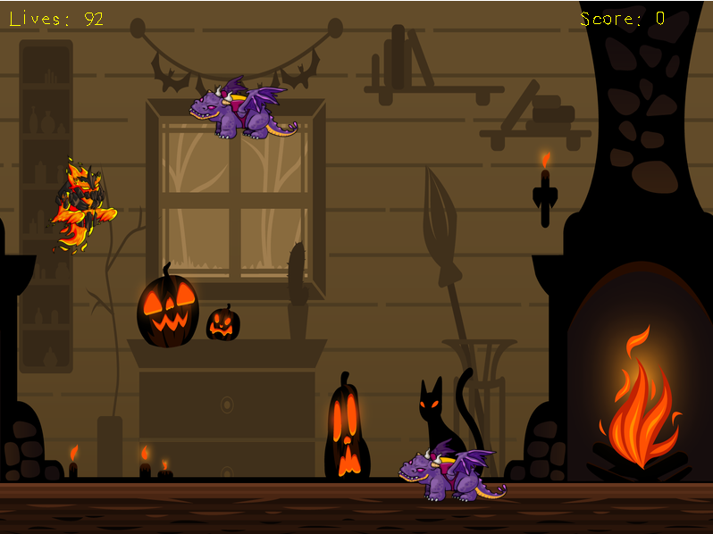

**Figure 3: Level 1 Screen**

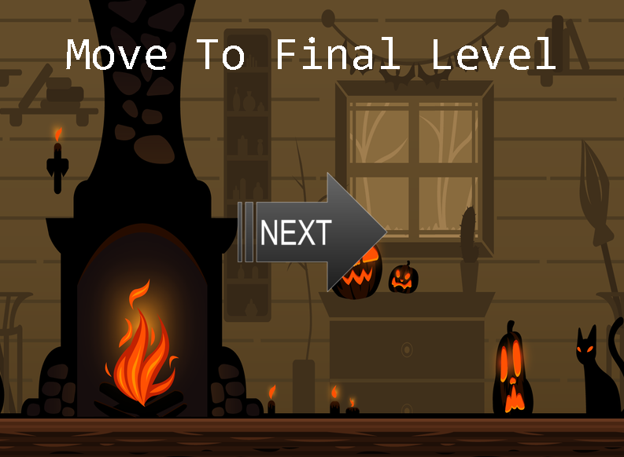

**Figure 4: Next Level Transition Scene**

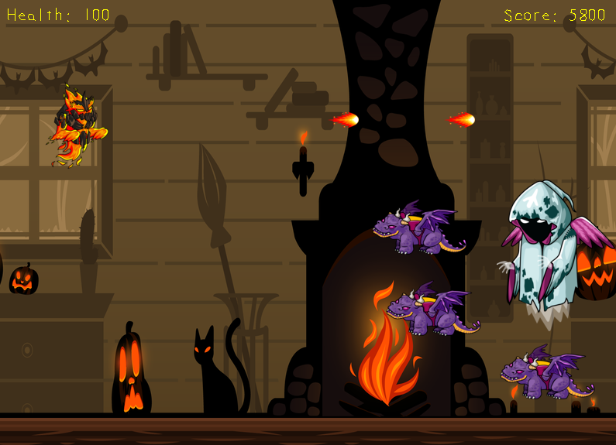

**Figure 5: Boss Level**

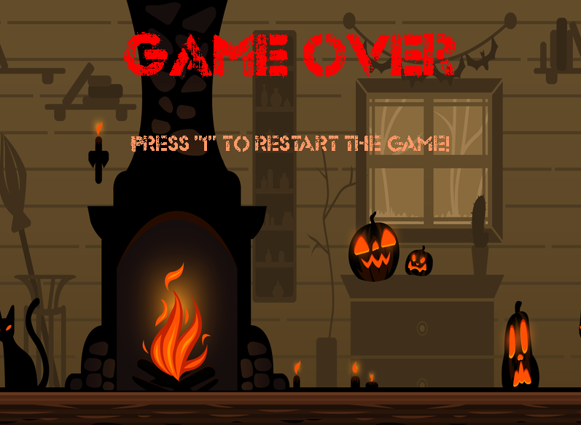

**Figure 6: Game Over Screen**

1. **Game World**

It is based on a Halloween theme, where player, enemies, and the boss are in Halloween costumers. To make the theme believable, all graphics are related to Halloween theme. There are flying dragons as enemies, Ghost as a boss.

1. **Levels**

*Level 1: It starts with enemies only. Killing first 10 enemies, gives a power up, that gives the player ability to throw 2 flames at a time! Killing next 10 enemies, gives another power up that allows the player to throw flames in 3 directions.*

*Score 5000 points to move to next level.*

*Level 2 or the Boss Level: The same enemies appear again but it’s endless wave. Kill the boss to win the game!*

1. **Characters**

The player is Elemental Fire and can throw flames around.



1. **Enemies**

There is just one type of enemy in the game for now. It’s a purple dragon that moves around the screen. If the enemy hits the player, it can reduce the player’s health by 4 points.

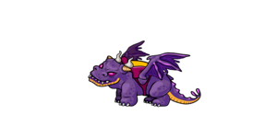

*There is a boss at the end.*

1. **Weapons**

*The player has a flame as weapon. Player can throw unlimited flames to kill the enemies and boss.*

*Flame can be doubled or tripled by picking up powerups that are automatically generated once a particular number of enemies are killed.*

1. **Scoring**+100 Points for killing each enemy

-4 Points if the enemy hits the player  
More powers ups available in the game

1. **Sound Index**

*No Sound Clips*

1. **Art / Multimedia Index**

|  |  |
| --- | --- |
|  | *1_fire_1.png* |
|  | *Boss.png* |
|  | *background (3).png* |
|  | *dragon (1).png* |
|  | *Home.png*  *Next.png*  *Play.png* |
|  | *Instructions.png* |
|  | *Start.png* |
|  | *Bonus.png* |